Required resources:
- Source : Onpermise SQL Server
- Destination : SnowFlake
- Orchestration : Azure Data Factory
- Transformation : Azure Databricks - Pyspark
- Storage Account : Azure datalake Gen2 Storage
- IR : Self-host Integration Resources
- app registration
- key vaults
- Linked services
- Lucidchart- for pipeline flow diagram.

Phase 1: Azure Infrastructure Setup

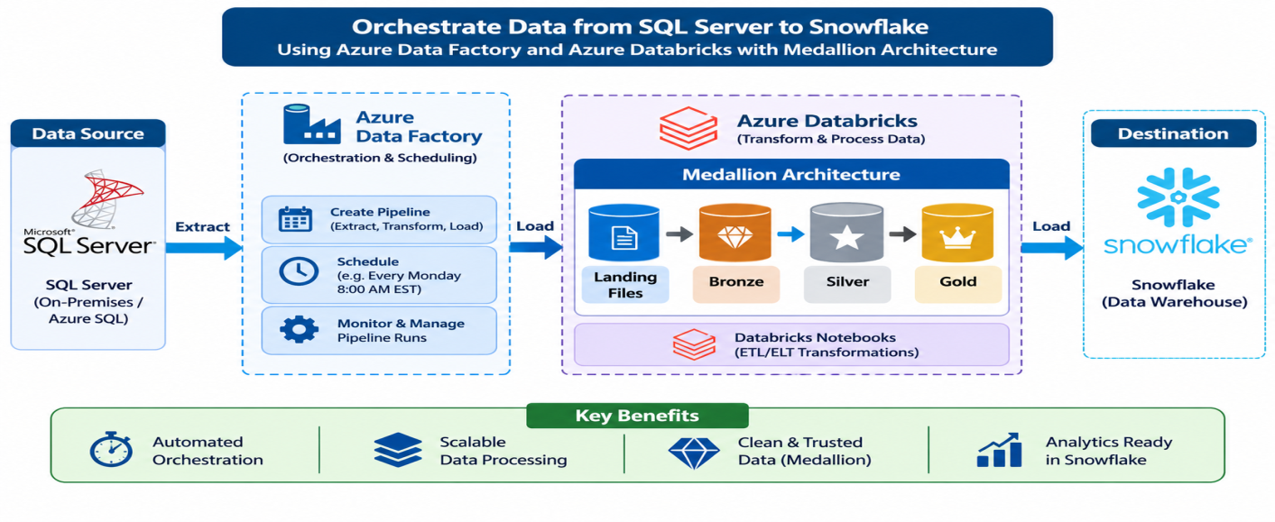

Flow-Diagram

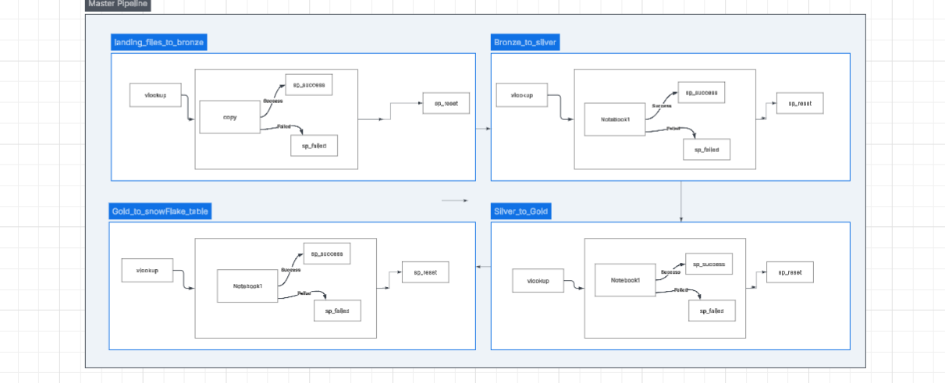

Lucid Chart_path – copy below link and paste it in own browser for best view above lucid chart.

https://lucid.app/lucidchart/3e08c246-d174-44aa-a9d9-6b2b7267d3bf/edit?viewport_loc=-725%2C698%2C3975%2C1431%2C0_0&invitationId=inv_281a54e2-2494-4066-918f-3b961058a854

Step 1.1: Create Resource Group
GUI Steps:
- Go to Azure Portal
- Click "Create a resource" → Search "Resource group"
- Fill in:
  - Subscription: Our subscription detail
  - Resource group name: rg-yt-dev-centralus
  - Region: Central India
- Click "Review + create" → "Create"

Step 1.2: Create Storage Account (ADLS Gen2)
- Click "Create a resource" → Search "Storage account"
- Fill in:
  - Subscription: Our subscription detail
  - Resource group: rg-yt-dev-centralus
  - Storage account name: stytdev001
  - Region: Central India
  - Performance: Standard
  - Redundancy: Locally-redundant storage (LRS)
- Click "Advanced" tab:
  - Enable hierarchical namespace: Checked ✓
- Click "Review + create" → "Create"

Step 1.3: Create Containers
GUI Steps:
- Go to your storage account →Data Storage - > "Containers" (left menu)
- Click "+ Container" for each:
  - Name: landingfiles → Public access level: Private → Create

Step 1.3: Create Containers
GUI Steps:
- Go to your storage account →Data Storage - > "Containers" (left menu)
- Click "+ Container" for each:
  - Name: bronze → Public access level: Private → Create

Uploading data into container
- Go to storage account bankingstorageprojecto1
- Click "Containers" → Click "landingfiles"
- Click "Upload" → "Browse for files"
- Select all 1 CSV files:
  - fare_rules.csv
  - kolkata_locations.csv
  - kolkata_weather_events.csv
  - payment_methods.csv
  - taxi_drivers.csv
  - taxi_vehicles.csv
  - trip_details.csv
  - yellow_taxi_trips.csv
- Click "Upload"

Step 1.4: Create Databricks Workspace
GUI Steps:
- Click "Create a resource" → Search "Azure Databricks"
- Fill in:
  - Workspace name: dbw-yt-dev-centralus
  - Resource group: rg-yt-dev-centralus
  - Location: Central India
  - Pricing Tier: Premium (required for Unity Catalog)
- Click "Review + create" → "Create"

Step 1.5: Create apps Registration
GUI Steps:
- Click "Create a resource" → Search " apps Registration”
- Fill in.
- New Registration: app-yt-dev-adls-access
- New Secrets – app_yt_client_secret
We will get below information
- Client – Id and Tenant ID will get from Overview
- Client-Secrets will get value when we are creating New Secrets

- Go to Storage Account and click IAM
- Click RBAC
- Select BLOB Storage Data Contributor
- Select member as app-hms-dev-adls-access registration and Assign access.

Step 1.6: Create Key Vault
GUI Steps:
- Click "Create a resource" → Search " Key Vault”
- Fill in.

- Resource group: rg-yt-dev-centralus
- Key vault name: kv-yt-dev-centralus-001
- Location : Central India
- Pricing Tier : standard
In Access configuration tab we need to select Azure Role Based Access control
- Click "Review + create" → "Create"

- Grant access Key vault administrator for creating secrets in key vault.

- Go to IAM click <add> Role assignment
- Search key vault administrator and select
- Click member and select portal id

- Grant access Key vault secret user

- Go to IAM click <add> Role assignment
- Search key vault secret user and select
- Click member and select AzureDatabricks

- we created two secrets below

- Client ID : app-yt-client-id
- Client Secrets : app-yt-client-secret

Step 1.6: Create Scope
GUI Steps:
- Click below address on browser search bar.
https://adb-7405618662963717.17.azuredatabricks.net/?o=7405618662963717#secrets/createScope
- Fill in.
Scope Name : app_yt_scope
DNS Name : key vault id from key vault properties
Resource id : Resource id from key vault properties

Display Scope –
dbutils.secrets.listScopes()
Display all Secrets for particular Scope.
dbutils.secrets.list(scope='app_yt_scope')

Step 1.6: Azure Data Factory

- Click "Create a resource" → Search "Data factory"
- Fill in:
  - Workspace name: Adf-yt-dev-centralus
  - Resource group: rg-yt-dev-centralus
  - Location: Central India
- Click "Review + create" → "Create"

Step 1.7: Integration Runtime
- In azure data factory , click on “manage -> Integration runtime -> new -> Self Hosted”
- Fill in :
Name - SHIR-yt-dev-centalus001
Click -> Create
Step 1.7: Link Service
- In azure data factory, click on “manage -> link service -> new -> search Key vault/snowflake/adlsgen2/OnpermiseSQLServer” select as per you request.
- Fill in below Detail:
For Azure Key vault - AzureKv_yt_centralus
For SnowFlakse - LS_SnowFlake_ytdb
For OnpermiseSQLServer – OnpermiseSQLserver
For adls link service - LS_yt_adls_gen2

Click -> Create.

Note - NB_LANDLINGFILES_TO_Bronze_layer

#create variable for storage account
Storage_name = "stytdev001"

#Configure Oauth authentication

spark.conf.set(
f"fs.azure.account.auth.type.{Storage_name}.dfs.core.windows.net",
"OAuth"
)

spark.conf.set(
f"fs.azure.account.oauth.provider.type.{Storage_name}.dfs.core.windows.net",
"org.apache.hadoop.fs.azurebfs.oauth2.ClientCredsTokenProvider"
)

spark.conf.set(
f"fs.azure.account.oauth2.client.id.{Storage_name}.dfs.core.windows.net",dbutils.secrets.get(scope="app_yt_scope", key="app-yt-client-id"))

spark.conf.set(
f"fs.azure.account.oauth2.client.secret.{Storage_name}.dfs.core.windows.net",dbutils.secrets.get(scope="app_yt_scope", key="app-yt-client-secrets"))

spark.conf.set(
f"fs.azure.account.oauth2.client.endpoint.{Storage_name}.dfs.core.windows.net",
"https://login.microsoftonline.com/65583477-d432-469c-b4af-ab046853916f/oauth2/v2.0/token",
)

#create Widget for Table_name and Storage_path

dbutils.widgets.text('TABLE_NAME','')
dbutils.widgets.text('STORAGE_PATH','')

TABLE_NAME = dbutils.widgets.get('TABLE_NAME')
STORAGE_PATH = dbutils.widgets.get('STORAGE_PATH')

#create source and sink path

source_path = f"abfss://global@{Storage_name}.dfs.core.windows.net/landingfiles/"
sink_path = f"abfss://global@{Storage_name}.dfs.core.windows.net/bronze/"

# STORAGE_FOLDER_NAME = TABLE_NAME + '_output/'

full_source_path = source_path + STORAGE_PATH + '/' + TABLE_NAME + '.csv'
full_sink_path = sink_path + STORAGE_PATH + '/' + TABLE_NAME

print(full_source_path)
print(full_sink_path)

# display(dbutils.fs.ls(source_path))

abfss://global@stytdev001.dfs.core.windows.net/landingfiles/kolkata_locations_output/kolkata_locations.csv
abfss://global@stytdev001.dfs.core.windows.net/bronze/kolkata_locations_output/kolkata_locations

#read and write data

df = spark.read.format("csv").option("header", "true").option("inferSchema", "true").load(full_source_path)

df_count = df.count()
print(f'with duplicate Data count is : {df_count}')

df_distinct = df.distinct()

df_distinct_count = df_distinct.count()
print(f'without duplicates count is :{df_distinct_count}')

df_distinct.write.format("csv").mode("overwrite").option("header", "true").save(full_sink_path)

print(f'Souce data Count is : {df_count} and destination data count is : {df_distinct_count}')

with duplicate Data count is : 27
without duplicates count is :20
Souce data Count is : 27 and destination data count is : 20

NB_BRONZE_TO_SILVER_LAYER

#import required module

from pyspark.sql.functions import *
from pyspark.sql import *
from pyspark.sql.types import *

#define storage account
Storage_name = "stytdev001"

#Configure Oauth authentication

spark.conf.set(
f"fs.azure.account.auth.type.{Storage_name}.dfs.core.windows.net",
"OAuth"
)

spark.conf.set(
f"fs.azure.account.oauth.provider.type.{Storage_name}.dfs.core.windows.net",
"org.apache.hadoop.fs.azurebfs.oauth2.ClientCredsTokenProvider"
)

spark.conf.set(
f"fs.azure.account.oauth2.client.id.{Storage_name}.dfs.core.windows.net",dbutils.secrets.get(scope="app_yt_scope", key="app-yt-client-id"))

spark.conf.set(
f"fs.azure.account.oauth2.client.secret.{Storage_name}.dfs.core.windows.net",dbutils.secrets.get(scope="app_yt_scope", key="app-yt-client-secrets"))

spark.conf.set(
f"fs.azure.account.oauth2.client.endpoint.{Storage_name}.dfs.core.windows.net",
"https://login.microsoftonline.com/65583477-d432-469c-b4af-ab046853916f/oauth2/v2.0/token",
)

#create widget for table name and storage path

dbutils.widgets.text('TABLE_NAME','')
dbutils.widgets.text('STORAGE_PATH','')

TABLE_NAME = dbutils.widgets.get('TABLE_NAME')
STORAGE_PATH = dbutils.widgets.get('STORAGE_PATH')

#define source and sink path

source_path = f"abfss://global@{Storage_name}.dfs.core.windows.net/bronze/"
sink_path = f"abfss://global@{Storage_name}.dfs.core.windows.net/silver/"

# STORAGE_FOLDER_NAME = TABLE_NAME + '_output/'

full_source_path = source_path + STORAGE_PATH + '/' + TABLE_NAME + '/'
full_sink_path = sink_path + STORAGE_PATH + '/' + TABLE_NAME

print(full_source_path)
print(full_sink_path)

abfss://global@stytdev001.dfs.core.windows.net/bronze/fare_rules_output/fare_rules/
abfss://global@stytdev001.dfs.core.windows.net/silver/fare_rules_output/fare_rules

#read and write data with requied information

df = spark.read.format("csv").option("header", "true").option("inferSchema", "true").load(full_source_path)\
.withColumn("ACTION_TIMESTAMP", current_timestamp())\
.withColumn("Created_by", lit("Tom"))\
.withColumn("batch_id", date_format(current_timestamp(), "yyyyMMddHHmmss"))\
.withColumn("_Source_file_Name", input_file_name())

df.write.format("csv").mode("overwrite").option("header", "true").save(full_sink_path)

NB_SILVER_TO_GOLD_LAYER

#import required module

from pyspark.sql.functions import *
from pyspark.sql import *
from pyspark.sql.types import *

#Define Storage_name
Storage_name = "stytdev001"

spark.conf.set(
f"fs.azure.account.auth.type.{Storage_name}.dfs.core.windows.net",
"OAuth"
)

#configure Oauth authentication

spark.conf.set(
f"fs.azure.account.oauth.provider.type.{Storage_name}.dfs.core.windows.net",
"org.apache.hadoop.fs.azurebfs.oauth2.ClientCredsTokenProvider"
)

spark.conf.set(
f"fs.azure.account.oauth2.client.id.{Storage_name}.dfs.core.windows.net",dbutils.secrets.get(scope="app_yt_scope", key="app-yt-client-id"))

spark.conf.set(
f"fs.azure.account.oauth2.client.secret.{Storage_name}.dfs.core.windows.net",dbutils.secrets.get(scope="app_yt_scope", key="app-yt-client-secrets"))

spark.conf.set(
f"fs.azure.account.oauth2.client.endpoint.{Storage_name}.dfs.core.windows.net",
"https://login.microsoftonline.com/65583477-d432-469c-b4af-ab046853916f/oauth2/v2.0/token",
)

#define widgets for table_name and storage path

dbutils.widgets.text('TABLE_NAME','')
dbutils.widgets.text('STORAGE_PATH','')

TABLE_NAME = dbutils.widgets.get('TABLE_NAME')
STORAGE_PATH = dbutils.widgets.get('STORAGE_PATH')

#define source and sink path and write data into gold layer

source_path = f"abfss://global@{Storage_name}.dfs.core.windows.net/silver/"
sink_path = f"abfss://global@{Storage_name}.dfs.core.windows.net/gold/"

# STORAGE_FOLDER_NAME = TABLE_NAME + '_output/'

full_source_path = source_path + STORAGE_PATH + '/' + TABLE_NAME + '/'
full_sink_path = sink_path + STORAGE_PATH + '/' + "dim_" + TABLE_NAME

print(full_source_path)
print(full_sink_path)

df = spark.read.format("csv").option("header", "true").option("inferSchema", "true").load(full_source_path)

df.write.format("csv").mode("overwrite").save(full_sink_path)

NB_GOLD_SNOWFLAKE_DATABASE
#import required module

from pyspark.sql.functions import *
from pyspark.sql import *
from pyspark.sql.types import *

#define variable
Storage_name = "stytdev001"

#configure authentication for storage
spark.conf.set(
f"fs.azure.account.auth.type.{Storage_name}.dfs.core.windows.net",
"OAuth"
)

spark.conf.set(
f"fs.azure.account.oauth.provider.type.{Storage_name}.dfs.core.windows.net",
"org.apache.hadoop.fs.azurebfs.oauth2.ClientCredsTokenProvider"
)

spark.conf.set(
f"fs.azure.account.oauth2.client.id.{Storage_name}.dfs.core.windows.net",dbutils.secrets.get(scope="app_yt_scope", key="app-yt-client-id"))

spark.conf.set(
f"fs.azure.account.oauth2.client.secret.{Storage_name}.dfs.core.windows.net",dbutils.secrets.get(scope="app_yt_scope", key="app-yt-client-secrets"))

spark.conf.set(
f"fs.azure.account.oauth2.client.endpoint.{Storage_name}.dfs.core.windows.net",
"https://login.microsoftonline.com/65583477-d432-469c-b4af-ab046853916f/oauth2/v2.0/token",
)

#define widgets for table name and storage path

dbutils.widgets.text('TABLE_NAME','')
dbutils.widgets.text('STORAGE_PATH','')

TABLE_NAME = dbutils.widgets.get('TABLE_NAME')
STORAGE_PATH = dbutils.widgets.get('STORAGE_PATH')

#Define source and sink path

source_path = f"abfss://global@{Storage_name}.dfs.core.windows.net/gold/"

# STORAGE_FOLDER_NAME = TABLE_NAME + '_output/'

full_source_path = source_path + STORAGE_PATH + '/' + "dim" + TABLE_NAME + '/'
full_sink_path = "dim_" + TABLE_NAME

print(full_source_path)
print(full_sink_path)

abfss://global@stytdev001.dfs.core.windows.net/gold/fare_rules_output/dimfare_rules/
dim_fare_rules

#read Data
df = spark.read.format("csv").option("header", "true").option("inferSchema", "true").load(full_source_path)

sfOptions = {
"sfURL": "PNKPEWR-BW37274.snowflakecomputing.com",
"sfUser": "AFZAL1991",
"sfPassword": dbutils.secrets.get(
scope="app_yt_scope",
key="snowflake-password"
),
"sfDatabase": "YELLOW_TAXI_DB",
"sfSchema": "YELLOW_TAXI_SCHEMA",
"sfWarehouse": "COMPUTE_WH",
"sfRole": "ACCOUNTADMIN"
}

SNOWFLAKE_SOURCE_NAME = "net.snowflake.spark.snowflake"

#Write data into snowflake yellow_taxi_db database

df.write \
.format("net.snowflake.spark.snowflake") \
.options(**sfOptions) \
.option("dbtable", full_sink_path) \
.mode("overwrite") \
.save()

- Data Source where all table are present.
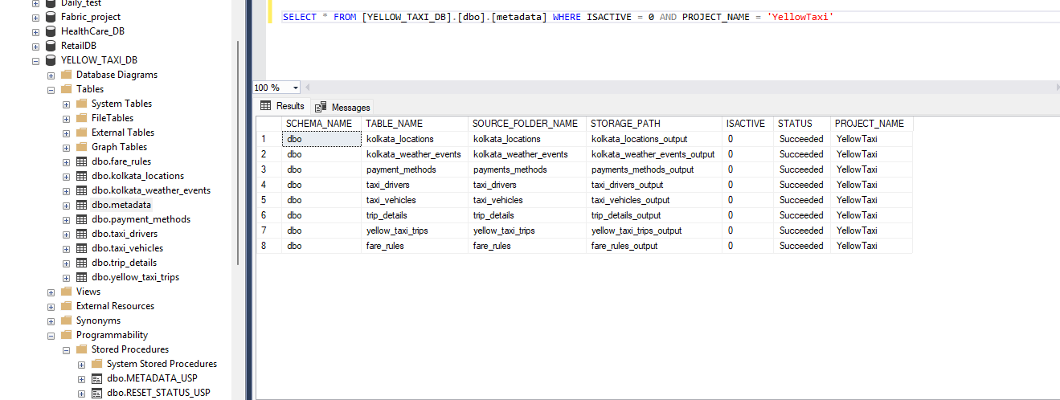

- Log Table before running Pipeline.

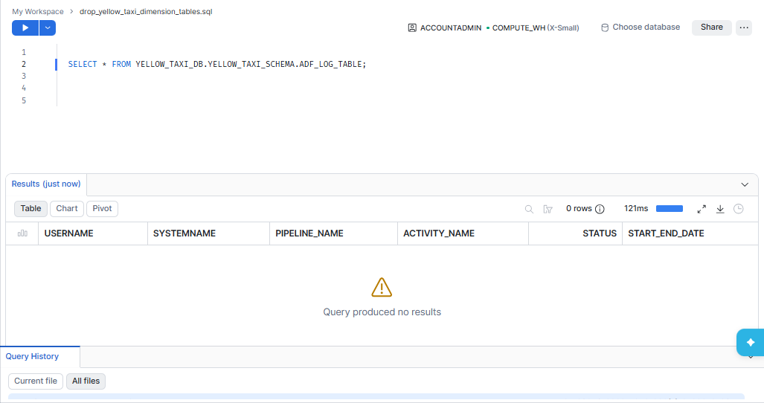

- Database in Destination before triggering master pipeline.
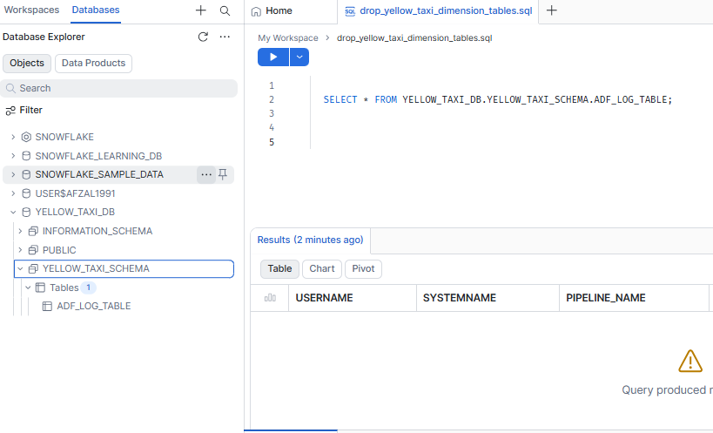

- Start Master Pipeline triggering for full_load data into Snowflake database.
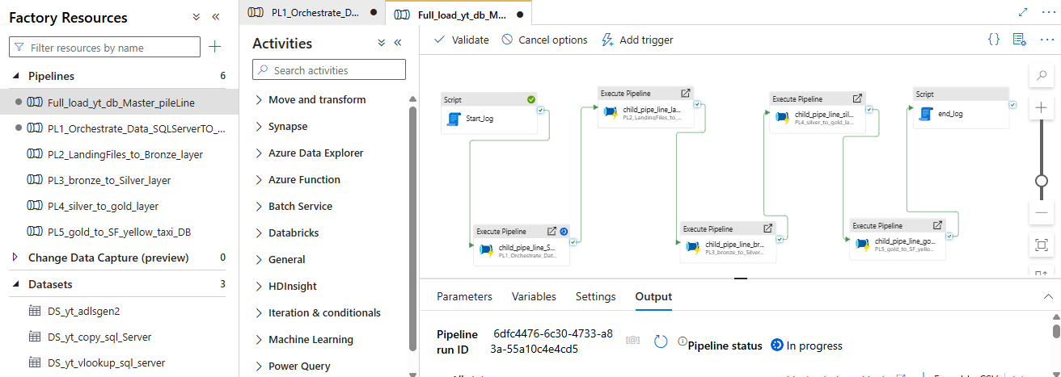

- Finally Master Pipeline triggered

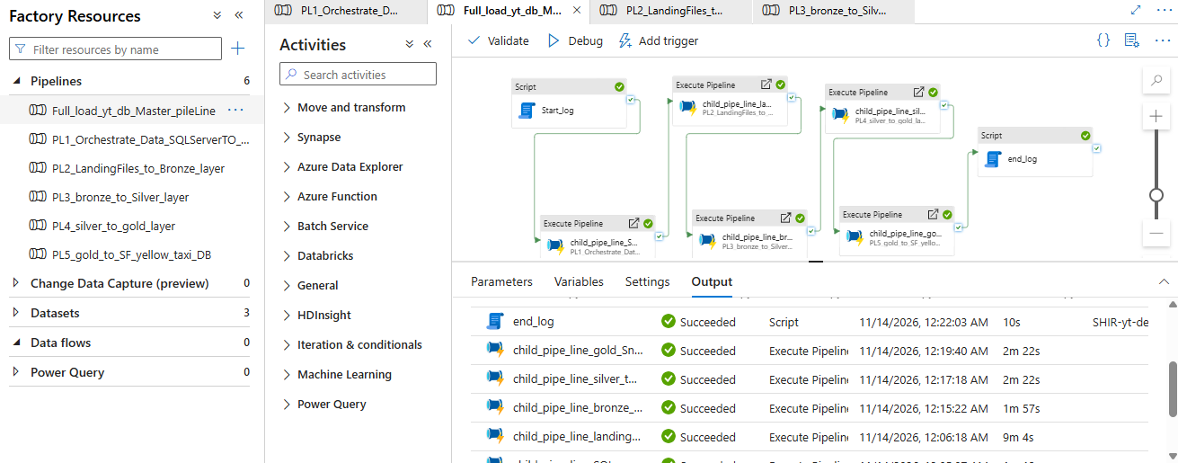

- Finally Data Loaded in Snowflake Destination Location

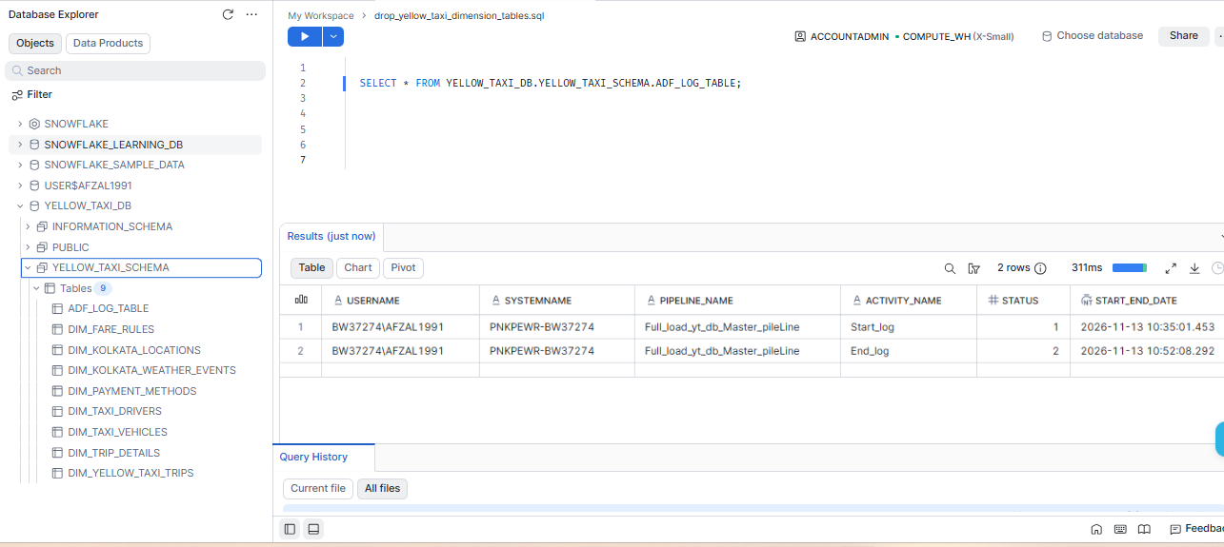

Project developed for Full Load data.

